**Introduction**

This business plan template is what we used for starting our web & graphic design studio, [Happycry](http://www.google.com/url?q=http%3A%2F%2Fwww.happycry.co.uk&sa=D&sntz=1&usg=AFQjCNFeHoxMzWWPscTl7iRhhnbas4rUtw). It doesn’t contain any of our original content (that would be daft), but it does show the structure we used with a short explanation for each section. As our business is web design, it’s geared towards the creative industry but the structure should apply to any businesses with a tweaks here and there.

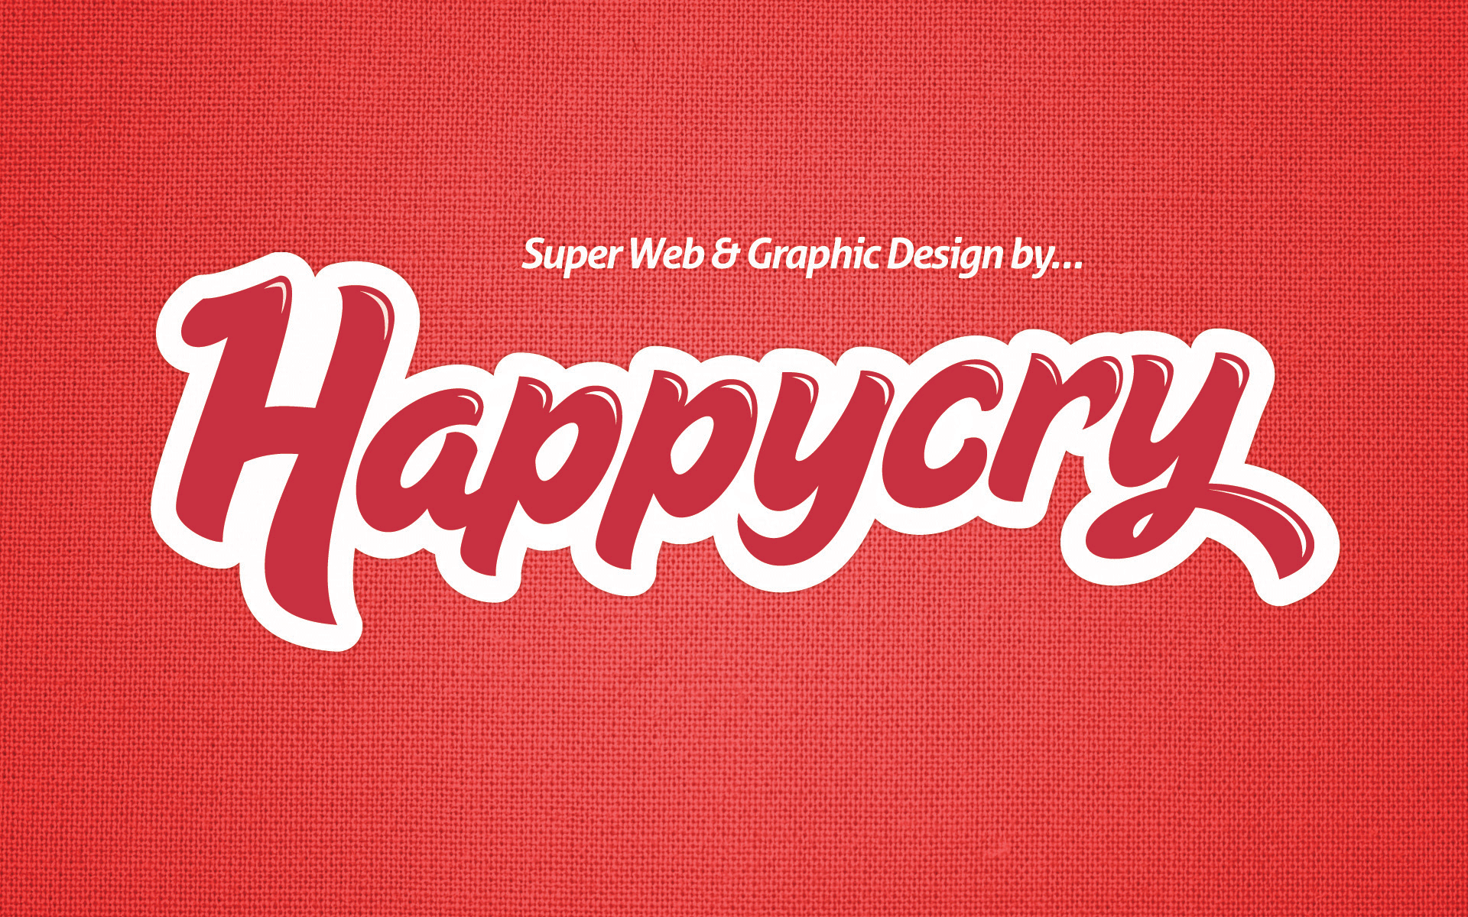

More details about the plan and why we released it can be found over at [this blog post.](http://www.google.com/url?q=http%3A%2F%2Fwww.happycry.co.uk%2Fblog%2Farchives%2Fstart_a_business_business_plan_template%2F&sa=D&sntz=1&usg=AFQjCNHK5_oEbsWF9hhE98D2NkT1Qa1WOw)

We release this template under a [creative commons license](http://www.google.com/url?q=http%3A%2F%2Fcreativecommons.org%2Flicenses%2Fby%2F3.0%2F&sa=D&sntz=1&usg=AFQjCNEkGjDdGkHbUbUnDvbQE_Uk1F0AJQ). Feel free to use it and share with other people. All we ask for is a link back to the blog post.





**Business Plan Template**

*Insert Business Name Here*

**Contents**

1. Confidentiality Agreement

2. Executive Summary

3. Business Focus

3.1 - Mission Statement

3.2 - Business Details

3.3 - Professional Support

3.4 - Personal Profiles

3.5 - Operations

3.6 - Operation Cycle

3.7 - Payment

3.8 - Aims & Objectives

4. Market Research

4.1 - Client Research

4.2 - Evidence of Customer Demand

4.3 - Competitor Profiling

4.4 - SWOT Analysis

5. Marketing Plan

5.1 - Service

5.2 - Unique Selling Point

5.3 - Pricing Policy

5.4 - Sales & Marketing Strategy

6. Financial Plan

6.1 - Start Up Costs

6.2 - Sales Forecasts

6.3 - Cash-flow Forecasts

6.4 - Other Financials

7. Appendix

## **1. Confidentiality Agreement**

It’s a good idea here to put some kind of confidentiality agreement between you and anyone that might read the plan. You don’t want to leave yourself open to people divulging your great business idea to any old Tom, Dick or Harry.

There’s a good example of an agreement on [this A List Apart Article](http://www.google.com/url?q=http%3A%2F%2Fwww.alistapart.com%2Farticles%2Fbusiness1%2F&sa=D&sntz=1&usg=AFQjCNEl9cJFvR25yZB1DlcJzi1hYoVyFQ)

## **2. Executive Summary**

The Executive Summary simply summarises the entire plan. Not everyone will have time to read every business plan they receive and will therefore use this summary to make a quick decision on whether they need to read all the fine detail or not.

Highlight the key areas of each section here to give readers a quick overview of what to expect.

## **3. Business Focus**

The business focus section details any aspect of how the business will be run, who will help set it up and any aims & objectives you have.

### **3.1 - Mission Statement**

This describes your overall objectives and aims as a business - *or* what you want to achieve and how you will achieve it. It’s the kind of thing you have on the wall in the office to remind you everyday why you’re doing this.

For us, our mission statement and Unique Selling Point (USP) are the same thing, so we just used our URP for this. There’s a great step-by-step guide over at Sitepoint that will help you define a USP: [6 Steps to Creating a USP](http://www.google.com/url?q=http%3A%2F%2Fwww.sitepoint.com%2Fblogs%2F2009%2F09%2F12%2Fhow-to-create-unique-selling-proposition%2F&sa=D&sntz=1&usg=AFQjCNGx2G_7vhmo49aIqFAv47Bntrmi9Q)

### **3.2 - Business Details**

A short introduction to the business, the founders, business location, your services and ethos. You can also put your **Legal Status** here too (e.g. Sole Trader, Partnership, Limited Liability Company). More info on legal status can be found on the [business link website](http://www.google.com/url?q=http%3A%2F%2Fwww.businesslink.gov.uk%2Fbdotg%2Faction%2Flayer%3Fr.s%3Dtl%26r.l1%3D1073858805%26r.lc%3Den%26topicId%3D1085161962&sa=D&sntz=1&usg=AFQjCNFmp31BQ5qLnXK6hj7KcLM-WIYp1w).

### **3.3 - Professional Support**

List the details of any professional support you have been receiving from an organisation or individual. For example we had a business advisor and [LJMU](http://www.google.com/url?q=http%3A%2F%2Fwww.ljmu.ac.uk%2F&sa=D&sntz=1&usg=AFQjCNEI8Ne27g1oPaPXFqPjxEGMBjrCrQ) who helped us with business support and funding.

### **3.4 - Personal Profiles**

Short profiles of anyone involved in setting up the business. Think of these as an informal CV/Résumé that gives some background on anyone involved in starting the business and why your starting a business.

### **3.5 - Operations**

This section details who will be involved in the operations of the business and what role they will have, e.g:

**Bob Smith - Creative Director**

*details about Bob’s role here…*

### **3.6 - Operation Cycle**

We used this section to describe the cycle of a typical project, from initial meeting to project completion. This can be helpful for readers of the plan to understand how your business works - they might not be experienced within your industry.

### **3.7 - Payment**

Details of your payment structure. This can include what percentage of payments you will take for deposit and project completion as well as invoice terms.

### **3.8 - Aims & Objectives**

This section lists what you want to achieve with your business and how you will achieve it. We split this into 3 sections

* + **Short Term**
  + Anything you want to achieve within the coming weeks and months (e.g. from now until 3 months).
  + **Medium Term**
  + Anything you want to achieve within the first year of operation. An example could be to target a certain turnover.
  + **Long Term**
  + We saw these as where we would like to see the company in 1-2 years.

## **4. Market Research**

This section is all about researching your customers and competitors and evaluating your prospective business against them. You need to show if there are **customers** and **demand** for your product and service.

### **4.1 - Client Research**

Here, we talked about where our client base would be founded and identified some problems they might have that our service could solve. It’s also a good idea to try and identify a **typical customer** based on your service and past experience. We found this particularly hard for web design as customers can vary a lot.

Instead of identifying a very specific customer, we identified sectors and markets to target our services and went from there in hope of finding a trend or niche.

### **4.2 - Evidence of Customer Demand**

To convince banks/investors/partners that your business plan is viable, you need to show that there is demand for your product or service. Evidence is key here, such as pre-agreed contracts or testimonials from previous clients you have worked for.

### **4.3 - Competitor Profiling**

As well as client research, you’ll need to look into competitors in your local (and, if relevant, national) area. We looked at competitors strengths, weaknesses and pricing, then compared them against ourselves. This was helpful in identifying our main competition in a similar price bracket to ourselves, but also larger companies that might be future competitors.

To do this research you might have to do a bit of digging. You can look at their websites for publicly available information, but details such as their pricing can be difficult to identify. Posing as a potential customer can be an effective way of getting some of their ballpark prices. It might not be totally accurate but it’s a start!

### **4.4 - SWOT Analysis**

The SWOT analysis is where you use your research to identify 4 things:

* + **Strengths**
  + What skills, knowledge, passion and connections do you have that can benefit your business plan and how will you get the maximum out of them to help build your business.
  + *Example: We are a partnership, so there is only two of us in the business that allows us to bring a personal and flexible approach to our business and clients.*
  + **Weaknesses**
  + What are the weaknesses of your business. It’s best to be open and honest about these and then show how you plan to overcome them.
  + *Example: We didn’t have any previous experiences running a business, which could make us liable to making mistakes. We have tried to overcome this by seeking professional advice where we can, such as business support schemes.*
  + **Opportunities**
  + What opportunities are out there that you can exploit to establish your business.
  + *Example: Through previous freelance work, one of us had links working with educational products which we plan to continue and could be a doorway into that sector.*
  + **Threats**
  + What are the threats to your business plan and what methods will you use to protect your business against them.
  + *Example: The design industry is a competitive industry with success rates for start-up business below 15%. To overcome this, we want to establish ourselves as a unique business, in our brand, our customer service and work quality.*

## **5. Marketing Plan**

The marketing plan is the section where you talk about how you will position and market your services including your USP, pricing policy and sales strategy.

### **5.1 - Service**

Here, go into detail about the services you plan to offer. It’s important to include enough detail as some people who read the plan might not be experienced in your industry.

We found it useful highlighting particular aspects and principles of our service(s) and relevant examples of previous work.

### **5.2 - Unique Selling Point**

What makes you different from other companies in your sector and why will customers want to use your service? This can be really difficult, but what we found helpful was identifying the simple things that customers want – unique does not have to mean crazy and different. A lot of companies fail their customers with simple problems such as good customer service.

As above, we used the the [6 Steps to Creating a USP](http://www.google.com/url?q=http%3A%2F%2Fwww.sitepoint.com%2Fblogs%2F2009%2F09%2F12%2Fhow-to-create-unique-selling-proposition%2F&sa=D&sntz=1&usg=AFQjCNGx2G_7vhmo49aIqFAv47Bntrmi9Q) article to identify a USP. Using that as a guide we structured it under these headings:

* + **Our target audience**
  + **The problem we solve**
  + **Three benefits of our service**
  + **What we will offer**

### **5.3 - Pricing Policy**

Ah, this old chestnut! This is probably the most asked about question on forums, blogs and Twitter for people looking to start out as a small business or freelancer. In reality, it’s not that difficult to devise once you have some sort of formula or logic behind your price.

We’ll be blogging about our formula for pricing in a couple of weeks, so keep an eye on our blog for that. Here are a few links from my Delicious archives that should help you out in the meantime:

[How 20 designers charge their clients – part 1](http://www.google.com/url?q=http%3A%2F%2Fwww.davidairey.com%2Fhow-designers-charge-their-clients-part-1%2F&sa=D&sntz=1&usg=AFQjCNHhDstS2-uueG_AafuU2r4Mz5MGTQ)

[The Fast, Good and Cheap Pricing Method](http://www.google.com/url?q=http%3A%2F%2Ffreelancefolder.com%2Fthe-fast-good-and-cheap-pricing-method%2F&sa=D&sntz=1&usg=AFQjCNE-VzbgmEFagmehcBMFFAykEQiCLA)

[How Much Should You Charge for a Website?](http://www.google.com/url?q=http%3A%2F%2Fcss-tricks.com%2Fhow-much-should-you-charge-for-a-website%2F&sa=D&sntz=1&usg=AFQjCNGOrn1L7no-cs6G8fXnmFAPeAKgdA)

[10 Resources to Help You Decide What To Charge for Design Work](http://www.google.com/url?q=http%3A%2F%2Fwww.acuitydesigns.net%2F10-resources-to-help-you-decide-what-to-charge-for-design-work%2F&sa=D&sntz=1&usg=AFQjCNF1w60RwjRSwxeuii51osnztZeHzA)

[FreelanceSwitch Hourly Rate Calculator](http://www.google.com/url?q=http%3A%2F%2Ffreelanceswitch.com%2Frates%2F&sa=D&sntz=1&usg=AFQjCNHZ7A-5_BxGwswCTuiHu6CFs0hE8Q)

### **5.4 - Sales & Marketing Strategy**

How are you going to market your product or service so that potential customers will know about it? Are you going to create any set packages that customers can buy off the shelf or will it all be on a bespoke basis?

For our marketing strategy, we split our plans up into **online** (website, blogging, social networking) and **offline** (mail drops, networking events etc.) strategies.

We didn’t have much of a budget for marketing and had to think of creative ways to market our services. You also have to think of methods that are relevant to your business though – For example, I wouldn’t say flyer or billboard advertising are suitable mediums for a web design agency.

## **6. Financial Plan**

This section is all about demonstrating your number crunching wizardry.

Have you identified start-up costs to get the business off the ground and forecasted sales for the first two years or so? The money men will want to see your cash-flow forecasts and make sure your books balance. Ultimately, they’ll be determining whether this is a financially viable business or not.

*To accompany this business plan template, there is a* [*financial planning spreadsheet*](https://docs.google.com/previewtemplate?id=0Ak4IcvXFn613dDlVVUFzMmdaNWZHY3B5bS1WdXZTS1E&mode=public) *you can use. You’re free to use the spreadsheet to calculate the financials and then copy and relevant tables and graphs here into the business plan.*

### **6.1 - Start Up Costs**

Illustrate your start-up costs here and demonstrate how you will finance them (you could refer to your cash-flow for this). Startup costs can include:

* Equipment
* Software
* Stationary
* Marketing materials

### **6.2 - Sales Forecasts**

Forecast sales for 1-2 years, or as many years as deemed necessary. This is difficult, but has to be done. It helps to use your knowledge of past clients/experience and then apply this to prospective client projects (e.g. you could generalise projects, such as: basic e-commerce website, branding design package, business card design).

Use your pricing calculations to calculate how many hours you have available in a week/month and how many projects you can fit within these hours. You could use your marketing strategy to illustrate when you expect to see a surge in sales or when you predict there might be a lull (e.g. Christmas period).

### **6.3 - Cash-flow Forecasts**

Your cash-flow is used to demonstrate your income and expenditure for each year, displayed on a month-by-month basis. **Income** can include sales, funding, loans etc. and **Expenditure** shows your outgoings such as rent, stationary and wages.

### **6.4 - Other Financials**

There are other tables you can include in your financial plan such as a profit & loss account for each year and a balance sheet. **Profit & loss** is fairly self-explanatory and a **balance sheet** shows your assets and liabilities.

We got more outside help with these other financial tables/charts than the rest of the business plan. There’s nothing wrong with that and I’d definitely [recommend getting help](http://www.google.com/url?q=http%3A%2F%2Fwww.happycry.co.uk%2Fblog%2Farchives%2Fstarting_a_design_business_get_the_ball_rolling%2F&sa=D&sntz=1&usg=AFQjCNF8z42wveRogzzC5j2P5pFdnVL3RA) with parts you’re uncertain about as well as your start-up plan as a whole.

## **7. Appendix**

The appendix is where you put additional information that is referenced in the business plan. This could be things such as:

* Financial charts / graphics
* CV’s / Resumes
* References
* Images of work
* Partnership Agreements